Case Study:

Learning Javascript to do the switching button.

My section is empty and I want to add some click to select style for it.

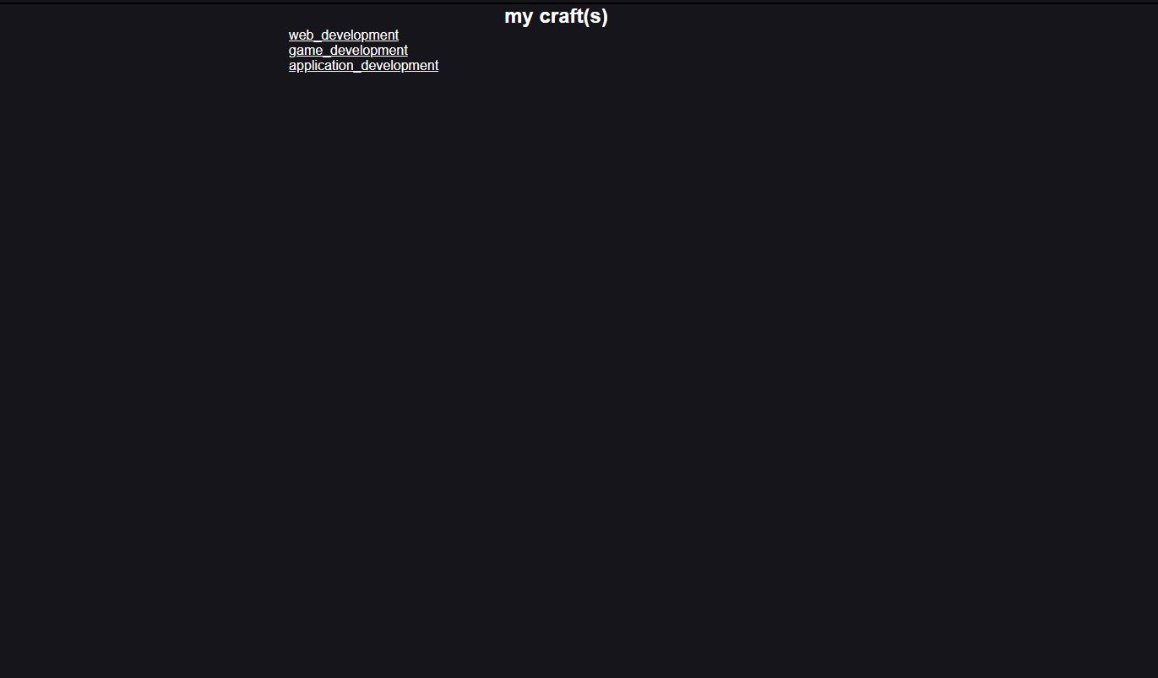

Low-prototype

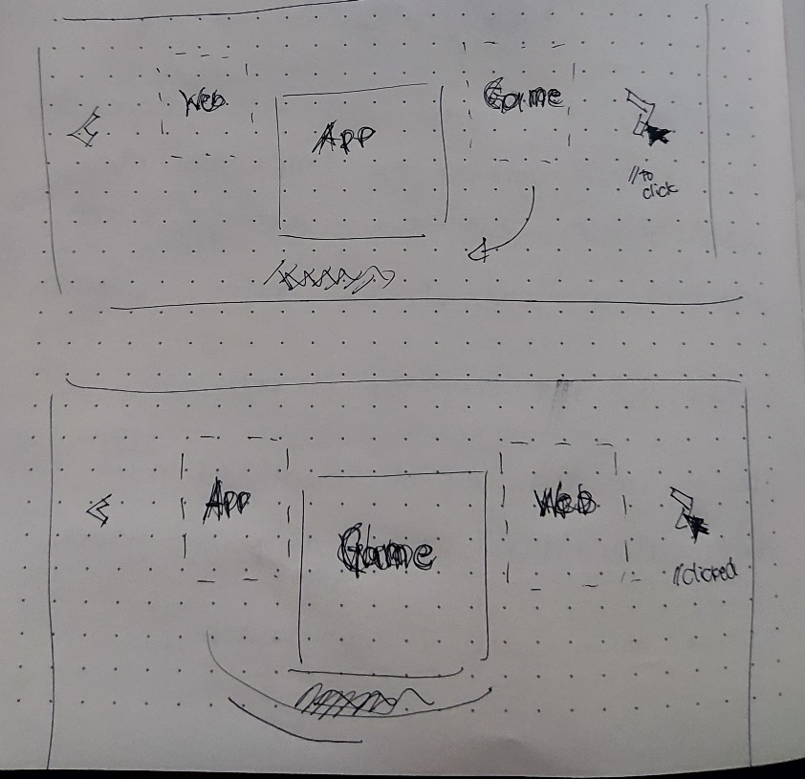

We cannot code it with html because it is only for the web’s structure. We cannot do it with css because it is only for the web’s styling. We see from the prototype that we need to interact with it to move those objects (web, app, game). And if it’s for interactions. Then we use javascript.

The problem however is I was busy on Godot Scripts, Flutter and Html-CSS but did not have no very basic coding knowledge of java script.